Igoumenitsa Port Data

IGOUMENITSA PORT DATA

Name of Port: IGOUMENITSA - GRIGO0003
Date Information Provided: Octomber, 2017
Name and Title: Andreas Ntais (President and Managing Director of Igoumenitsa Port Authority S.A.)

Item | General Port Information
Prevailing Weather | Winds:  1] The whole year, usually, var. prevailing winds with low intensity [15kn]  2] From April - October has been observed, squalls with NW winds, force up to 30kn  3] From November - March has been observed, squalls with W –NW winds, force up  to 30kn
 | Currents: N/A
 | Other:
Location(s) of pilot boarding areas | N / A
Approach channel width & depth at chart datum | Channel length : 1 nm  Channel depth : 10.5m  Channel width : 170m  Channel passage speed 11 kn  The channel in the ‘axis’ [middle of the channel] has been observed in the past, that congregate sand and creates sand mounds up to 2.5 meters.  The channel is newly dredged [2015] and the 60000 cm of sand removed.  Currently the ships which call the port have max draught of 7.5m, except the Cruise ship MARINA with draught 7.4m/ Thomson Celebration with draught 7.8m/ Thomson Spirit with draught 7.7m.  The channel’s depth is controlled and approved by the hydrographic service of the Greek Navy. That will be frequently done so we can ensure the safe navigation/passage.
Distance from pilot Sta. to dock/anchorage | Distance: Channel East entrance to the cruise pier 2.7nm
Estimated time from pilot station to dock/anchorage at max. speed allowed by port authority | Maximum channel passage speed as in the bay as well 11kn.  [ by calm seas and low wind force]  Estimated Channel passage and approach about 30’- 45’
Depth at chart datum and diameter of turning basin | Not specific turning basin available – its open bay
Air draft restrictions | N / A
Depth alongside pier at chart datum and uninterrupted length for which this depth occurs | Depth all the way along the port and alongside 10.5m
Port Established Max. draft | 10.5m
Port established Max. LOA | Total Pier Length 1197m - Cruise Pier Length 420m
Range of Tides & Max. Currents | Currents: N/A – Tide range max [+- 40cm]
Name/Draft/LOA of largest ship to safely call at port | Last call was the:  MARINA [Oceania cruises] – LOA: 239 – Draught: 7.4m  Thomson Celebration –LOA: 214.66 - Draught: 7.8m  Thomson Spirit - LOA: 214.7 - Draught 7.7m
Power, type and number of tugs available | t/b THYELA [build 1962]  POWER: 954 HP

Item | General Port Information
Are the tugs local (within 30 minutes from the port?) | Tug Boat compulsory STBY if any vessel approach in progress
How far in advance do tugs have to be ordered? | Tug info due to ‘ Igoumenitsa Traffic’
Item | Dock Information
Names, lengths,  and minimum  depths for all  cruise ship suitable berths | The port is mainly divided by two sections as per follow:  1] Ferry port from ramp 1 – 12 – total length 775m [Ferries alongside by the stern only]  2] Cruise port ramp 12 – 18 – total length 420m  3] Pier depth all the way along / alongside 10.5m
1] ARCH Fenders 420 KN x M
Every group has [4] fixed ARCH fenders every 1.5m – distance between the Fender groups about 35m

2] 6 x new YOKOHAMA [2.5m / 50 KN x M] Fenders available [movable according the vessel needs]

Pics attached

Bollards are from Cast Steel made.
Bollard spacing 30m
Bollard strength / pull : 100 Ton and 200 Ton available
 | N / A
 | Cement surface – 21000 sqm [pic attached]
TYPE and Spacing of Fenders | Both sides available
Bollard Spacing and bollard pull/strength | Height from flat surface 1.6m from the sea level  Height from ramp surface 1.9m from the sea level [pic attached]
Type and Number of Shore Gangways | Ramps with height: 30cm from
Type and surface of dock
Preferred side of ship alongside
Height of dock surface above charted low water datum
Pier Obstructions
Other

Item | Anchorage Information
Secure Anchorage(s) Position (Lat/Long)
Min depth of Anchorage
Type of Bottom
Wind Current
General Slope of Bottom
Distance to tender landing dock
Minimum Depth of Channel or Fairway to Tender Dock
Minimum Depth of Water at Tender Dock

ITEM | Tendering Information
Distance to tender landing dock from Anchorage
Minimum Depth of Channel or Fairway to Tender Dock
Minimum Depth of Water at Tender Dock
Number of tender berths (for 150 person ship tenders)
Fendering at Tender Berth
Type of Bitts/Bollards at Tender Berth
Height of tender dock above the water at low AND high tide
Describe the way passengers get on/off the tenders (are their steps, etc?)
Are the tender areas wheel chair accessible?

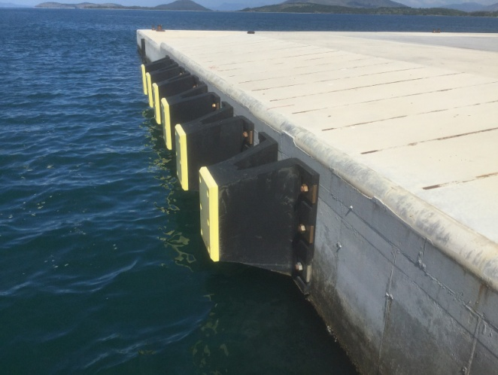  ARCH Fenders | 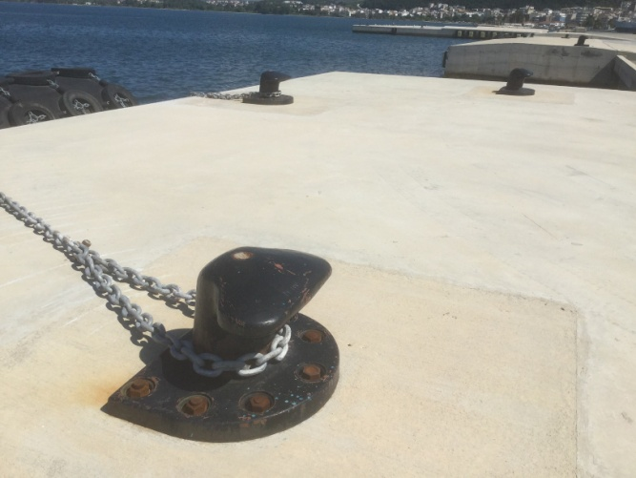  Bollards assignment
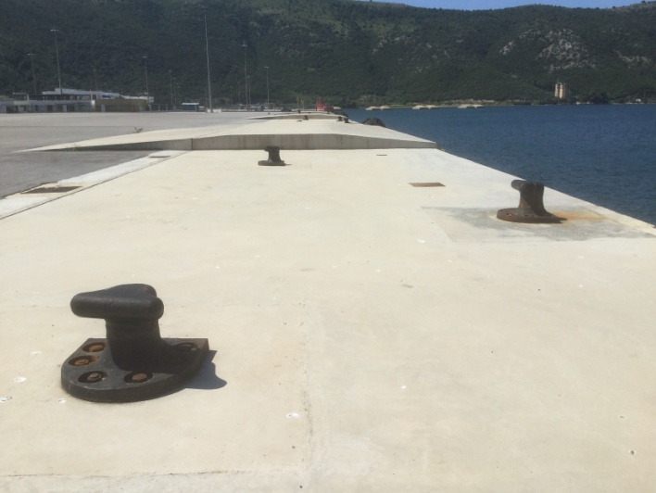  Pier heights [1.6 & 1.9m] | 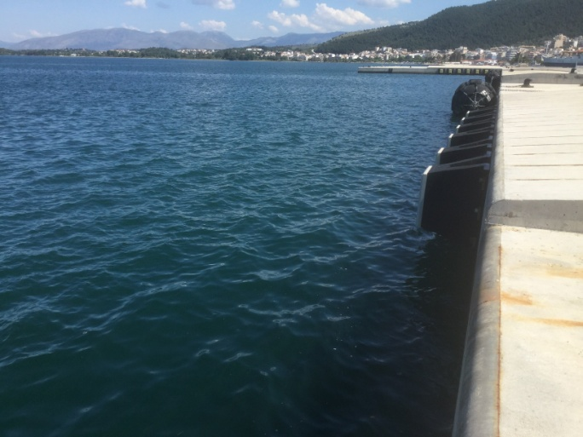  Pier length 420m
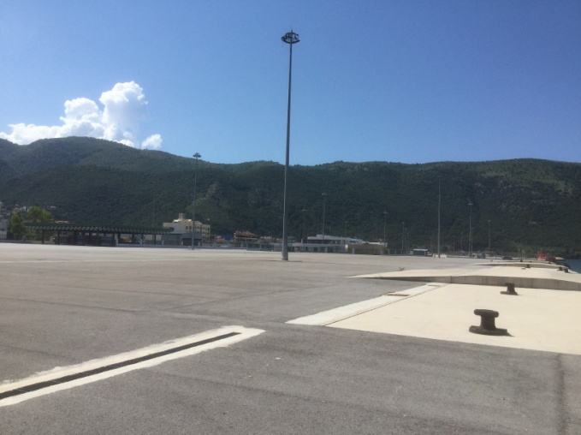  Port area view | 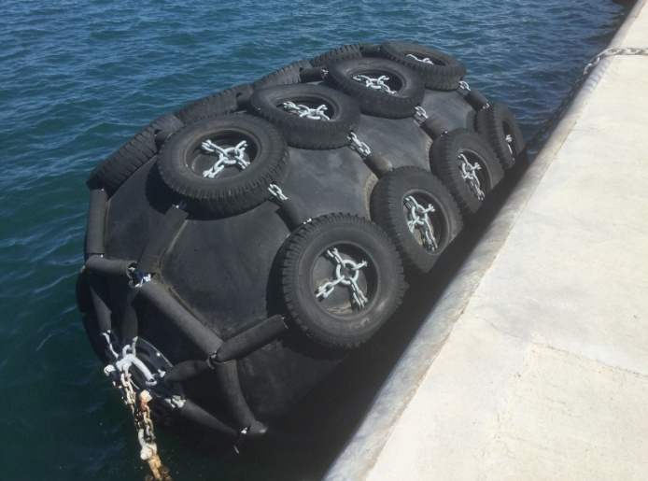  YOKOHAMA Fenders

